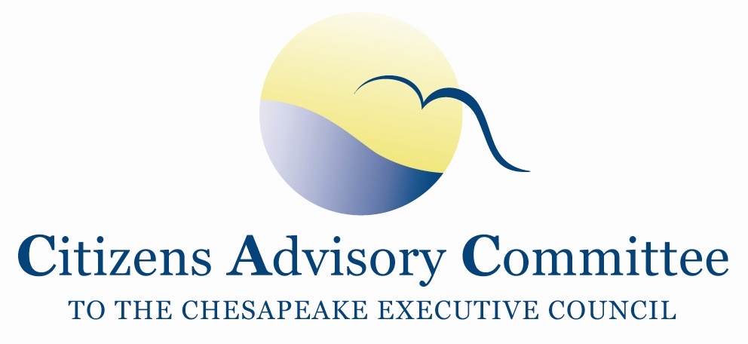
Citizens Advisory Committee
Meeting Agenda
November 21-22, 2019

______________________________________________________________________________________________________________________________________

Omni Shoreham Hotel
2500 Calvert Street, NW
Washington, DC 20008

Meeting Goals:
- Receive updates on CAC priority topics: Environmental Education and Workforce Development
- Provide Requested Feedback to the CBP Communications Workgroup

Thursday, November 21- The Executive Room

11:00 a.m. Call to Order and Welcome……………………….………………….…..Matt Ehrhart, Chair
- Introduction of Members and Guests
- Opening Remarks about Meeting Agenda

11:15 a.m. CAC Feedback Requested on Beyond Environmental Benefits Toolkit
Rachel Felver, CBP Communications Director

The Bay Program Communications Workgroup has created a toolkit with case studies and a database on restoration projects. The intended audiences are stakeholders and advocates that want to convince local decision makers to invest in conservation and water quality improvement projects by showing them how they also benefit the community and local economy.

12:00 p.m. Working Lunch
Presentation: DC’s Tree Canopy……………………John O’Neill, Urban Forester Ward 8
District Department of Transportation

1:00 p.m. Microplastics in the Water……………………………………………..Matt Robinson, DOEE
Bob Murphy, Fisheries Ecology Center for Ecological Sciences
Co-authors of the STAC workshop report entitled, Microplastics in the Chesapeake Bay and its Watershed: State of the Knowledge, Data Gaps and Relationship to Management Goals will provide an overview and answer questions.

1:45 p.m. Walking Tour of Nearby Restoration Site………….…………………………....Jeanne Braha
Executive Director, Rock Creek Conservancy
2:45 p.m. Return to Hotel
Break

3:00 p.m. CAC Priority: Environmental Education and Workforce Development
Panelists:
- Grace Manubay, Environmental Literacy Coordinator, DC Office of the State Superintendent of Education
- Arlen Herrell, Associate Director, DC Infrastructure Academy, DC Department of Employment Services
- Bernadette Harvey, Owner, BConstrux
- Queen Richardson, Alliance for the Chesapeake Bay
4:30 p.m. CAC Discussion

5:00 p.m. Meeting Recess

6:30 p.m. Dinner- LiLLiES Restaurant & Bar
The Restaurant is about a 10 minute walk from the hotel.
Members continue to discuss local river and Chesapeake Bay issues in an informal setting.

Friday, November 22- The Executive Room
Breakfast buffet available in the meeting room starting at 8:00am.
(Please Check out of the hotel before the meeting begins.)

8:30 a.m. Call to Order………………………...………………………..….…….…..Matt Ehrhart, Chair
- Approve September 2019 Meeting Minutes
- CAC Officer Elections
- CAC Member Updates and Announcements
- Staff Updates

9:30 a.m. Updates from the Chesapeake Bay Program…………………………..…………Jim Edward,
Deputy Director, EPA Chesapeake Bay Program Office
- BMP Verification
- Two-Year Milestones in the Watershed Implementation Plans
- CBP Funding

10:15 a.m. Break

10:30 a.m. CAC Discussion, Final Thoughts and Action Items
- Reflections on the Meeting Topics
- Discuss Action Items and Next Steps
- Ideas for February 2020 CAC meeting agenda in Harper’s Ferry, West Virginia

12:00 p.m. Adjourn
2020 CAC Meeting Dates:
February 20-21 in WV
May 21-22 in Richmond, VA
September 17-18 in PA
December 3-4 in St. Mary’s, MD

