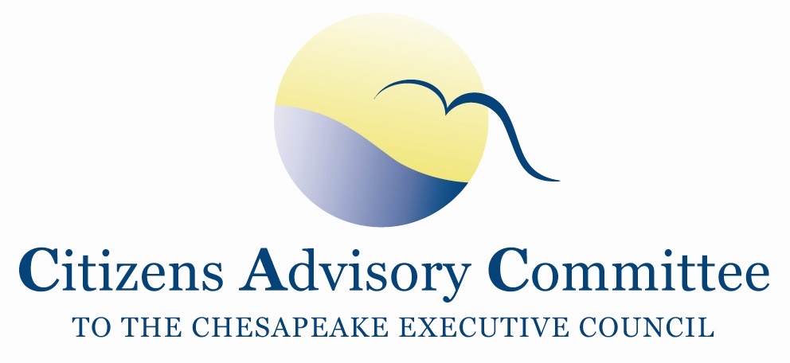
Citizens Advisory Committee
Meeting Agenda
September 7-8, 2017

______________________________________________________________________________________________________________________________________

Lake Raystown Conference Center
Huntingdon County
3101 Chipmunk Crossing
Entriken, PA 16638

Meeting Theme: Challenges and Opportunities for Pennsylvania Agriculture

Meeting Goal: (1) Learn ideas and successful approaches to protecting local water quality while supporting agricultural working lands. (2) Decide how and with whom the CAC will share the findings from the meeting.

Thursday, September 7- Blue Spruce Room

10:00 a.m. Call to Order………………………………………………………….…..Paula Jasinski, Chair
- Introduction of Members and Guests
- Opening Remarks about the meeting theme and objectives

10:15 a.m. Water Monitoring Trends and Storylines of Central PA………...…...Dr. Emily Trentacoste
Biologist, EPA Chesapeake Bay Program Office

Learn the about the trends, drivers, and explanations of local water quality based on synthesized data. Discuss the management implications and applicability for developing the TMDL’s Phase III Watershed Implementation Plans.

11:00 a.m. Precision Conservation in the Susquehanna River Watershed………………….. Carly Dean
Project Manager, Chesapeake Conservancy

Learn about a new approach to reduce nonpoint source pollution and improve wildlife habitat using technology that aims to improve efficiency, effectiveness, and returns on investment through better targeting of sites for conservation practices.

11:45 a.m. Panel Discussion

12:00 p.m. Lunch- U.S. Army Corps of Engineers (Invited)

1:00 p.m. Agriculture and Nutrient Management……………………………………Dr. Douglas Beegle
Professor of Agronomy, Penn State University

Learn a broader context of agriculture and nutrient management in the Chesapeake Bay Watershed.

2:00 p.m. Site Visits
- Wason Farm
This Swine finishing farm is operated by the Morningstar Family and is a Country View Family Farm partner. This farm houses over 2,000 pigs. We will see the swine barn and manure storage and learn how bringing the animals inside eliminates exposure to the severe and changing weather, controls disease, decreases mortality, keeps animals safe from predators, and reduces soil erosion. The swine barn’s ventilation system, water system, and feeding system are all customized to meet the animals’ needs. Manure is spread on local fields following the plan that meets crop needs. CAC member, Bill Fink, is our host for this site visit.
- Huntingdon Farm
Huntingdon Farm is a privately owned and managed business of John and Kathryn Dawes, under the management and supervision of William Shoemaker, farm manager. The operation is an American Angus Association member farm that is home to a registered herd of 50 head with 36 brood cows.

5:15 p.m. Return

5:30 p.m. Lake Boat Ride and Reception
Speaker- Dr. Dennis Johnson, Juniata College
Professor of Environmental Sciences and Studies, Department Chair

About the Lake: Raystown Lake is a reservoir in Huntingdon County, PA. It is the largest lake located entirely in PA and offers 8,300 surface acres of clear water surrounded by 21,000 acres of forested mountain slopes. Raystown is a multi-purpose lake constructed and managed by the U.S. Army Corps of Engineers for flood damage reduction, recreation and natural resource opportunities, and hydro-electric power. Much of the surrounding land is owned by the Army Corps of Engineers and is not available for residential development.

In February 2017 construction the Sunoco Pennsylvania Pipeline Project began. The Pennsylvania Pipeline will expand Sunoco’s existing pipeline systems and is expected to transport up to 700,000 barrels of natural gas liquids per day.

7:00 p.m. Dinner onsite- Garden Room

Friday, September 8- Blue Spruce Room
Breakfast will be available in the meeting room starting at 8:15 a.m.

8:30 a.m. Call to Order and Working Breakfast…………………………….…..Paula Jasinski, Chair
- Approve May 2017 Meeting Minutes
- Approve 2018 CAC Meeting Dates
- CAC Member Updates and de-brief from yesterday’s meeting

9:15 a.m. PA Department of Environmental Protection Updates……...…..Katie Hetherington Cunfer
Executive Director for External Affairs, PA DEP
- Pennsylvania in Balance- updates on the ‘Reboot’ Plan
- Findings from the PA DEP Phase III WIP Listening Sessions
- Mechanisms and approaches for delivering practices on the ground

10:30 a.m. Break

10:45 a.m. Updates from EPA Chesapeake Bay Program……………………………………Jim Edward
Deputy Director, EPA Chesapeake Bay Program Office
- Overview of Challenges and Opportunities for State Milestones and Phase III WIPs
- Overview of plans for EPA support for Phase III WIPs
- Briefing on BMP verification

11:15 a.m. CAC Discussion and Final Thoughts
- What are the findings and ideas from the discussion and how and where should CAC engage with this knowledge after the meeting?
- What is an appropriate role for CAC in Phase III WIP communications/development?

12:00 p.m. Adjourn

Next CAC Meeting is November 29-30 in DC.

