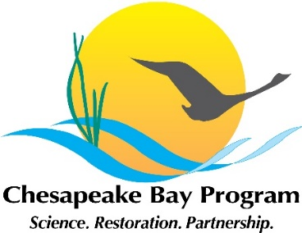
Stream Health Workgroup Meeting Agenda UPDATED
February 19, 2021, 10:00am-12:00pm
Click here to join the meeting
+1 202-991-0477
Phone Conference ID: 154 271 915#
This meeting will be recorded to ensure the accuracy of meeting minutes
10:00 | Introductions and Announcements – Co-Chairs Neely Law and Alison Santoro, Julianna Greenberg (CRC)  - 2021 Meeting Dates  - Updates from the Habitat Goal Implementation Team Fall Meeting  - Wetland Riparian Area STAC Workshop  - Water Temperature STAC Workshop  - Update on status of the GIT funding proposal
10:10 | USGS White Paper Updates – Rosemary Fanelli (USGS)
10:30 | Updates on the Healthy Watersheds Assessment – Renee Thompson (USGS)
10:50 | Filling Sampling gaps through Chesapeake Monitoring Collaborative – Liz Chudoba (CMC)
11:30 | Adjourn

