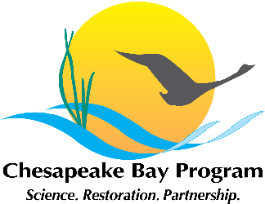

Toxic Contaminants Workgroup
Policy and Prevention meeting

December 18, 2014
1:00 p.m. – 3:00 p.m.

Conference Line: (866) 299-3188
Conference Code: (267) 985-6222
Web Access: https://epa.connectsolutions.com/tcw/

Agenda

- Welcome, Introduction
Greg Allen (EPA) (1:00 p.m. – 1:15 p.m.)
- Update on Actions and Decisions.

- Management Approaches used in the Delaware River Basin (1:15 p.m. – 2:15 p.m.)
Tom Fikslin, Delaware River Basin Commission (DRBC)
- Overview of the management approaches that DRBC took to reduce PCBs in the Delaware River Basin.
- Questions from the workgroup.
Materials:
II.a. – Fikslin PCB TMDL Presentation

- Management Strategy Development Framework (2:15 p.m. – 2:45 p.m.)
- Discussion of the organizational approach to developing the management strategy.
- Review of the initial rough draft of the Policy and Prevention management strategy.
Materials:
III.a. – Initial rough draft of Policy and Prevention management strategy

- Review of Actions and Decisions (2:45 p.m. - 3:00 p.m.)
- Discuss next steps.
- Identify writers and reviewers?
- One team to address each outcome?
- Clarify action items to advance strategy development.

