Toxic Contaminants Work Group

Example Management Activities

Example Management Activity 1: Coan River PCB Remediation.
The Potomac River PCB TMDL (Hayward and Buchanan, 2007) identifies a variety of sources contributing to PCB loads, some of which will require substantial load reductions in order to achieve TMDL targets. On-the-ground actions that might be implemented to achieve Potomac River PCB TMDL targets will be determined through ongoing and future TMDL processes, but may include BMPs such as sediment trapping/remediation BMPs that have been evaluated for co-benefits of contaminant reduction. These types of actions represent the most specific level (in terms of location and method) of activity that would be implemented through the auspices of the Toxic Contaminants Workgroup for which potential climate change effects can be assessed and accounted for. From information in Hayward and Buchanan (2007) on the general types of PCB sources that contribute to observed environmental concentrations, a fictitious example ‘project’ is presented that includes an arbitrarily selected, fictitious site on the Potomac River (a real location but not an actual facility or otherwise identified contaminated site), and presents a set of BMPs that might commonly be utilized to remediate PCB contamination, such as erosion and runoff of contaminated sediments, and groundwater (GW) contamination through leaching.

Example Activity
The Coan River on the lower Potomac in Virginia (identified as segment 10 in the PCB TMDL; Figure 1) has PCB contamination primarily from non-point sources of contaminated sediments, and atmospheric deposition (Hayward and Buchanan, 2007). No specific contaminated sites are identified in the TMDL, but for the purposes of this example activity, we are going to also say there is a (fictitious) ‘hotspot’ of legacy PCB sediment contamination near the bank of the river that has not be previously treated. Such a site could contribute eroded PCB-contaminated sediments, and also leach PCBs to groundwater (GW).
This example focuses on a combination of remediation BMPs:
- Install vegetated filter strips along the river and in particular adjacent to the ‘hotspot’ legacy contaminated site to reduce the load of contaminated sediment in the runoff before it enters the river.
- If there are stormwater collection and discharge, install vegetated filter strips for stormwater treatment.
- Install groundwater wells to pump and remove, and then treat, contaminated GW.
- There may be additional benefit from adding a sediment cap to the contaminant ‘hot spot’.

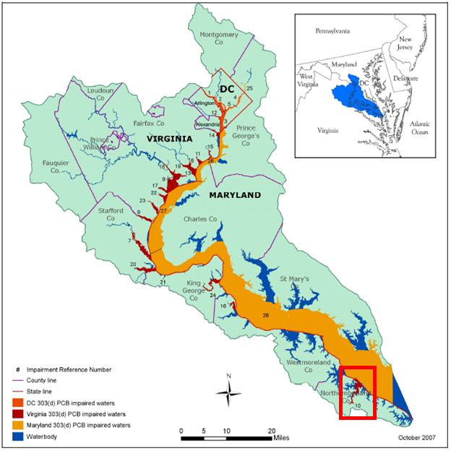
Figure 1. Potential contaminant (PCB) sites on the Potomac River, showing Coan River (segment 10) on the lower Potomac.

Additional Supporting Information
In general, contaminants may enter the river from any contaminated sites that border the river, as well as from other river segments or tributaries (Hayward and Buchanan, 2007). Contaminant entry pathways include erosion and transport of contaminated soil, contaminated runoff, and seepage of contaminated groundwater. The Coan River has an estimated PCB baseload of 15 grams/year total PCBs, and a TMDL load of 6.98 g/yr, representing a needed load reduction of 53.5%. Modeling in support of TMDL development showed that in addition to direct load reduction, meeting water column and sediment targets in the tidal Coan River would also require that the PCB concentration at the boundary with the Chesapeake Bay be reduced by 33% from the Baseline 0.108 ng/l to 0.072 ng/l PCB (Hayward and Buchanan, 2007). Meeting these targets also assume a 93% reduction in atmospheric deposition everywhere.

Example Management Activity 2: Potomac River PCB TMDL.

Example Activity
PCBs have been identified by the Toxic Contaminant Workgroup as a primary work plan focus, and total maximum daily loads (TMDLs) are a key mechanism through which Toxic Contaminant Workgroup goals will be implemented. The Potomac River PCB TMDL (Figure 2) has been published (Interstate Commission on the Potomac River Basin, 2007) and various recommended next steps are underway for filling data/information gaps and initiating remediation investigations. This TMDL will be used as a strawman for exploring where critical components or assumptions of the TMDL may be vulnerable to climate change (e.g., the assumptions regarding seasonality and critical flow conditions), and how they might be reviewed/revised. There are numerous potential intersections between the TMDL process and climate change assessment, which can be explored with regard to the Potomac River PCB TMDL. To help think about these, Figure 3 summarizes key elements of the TMDL process.
BMPs that might commonly be utilized to remediate PCB contamination 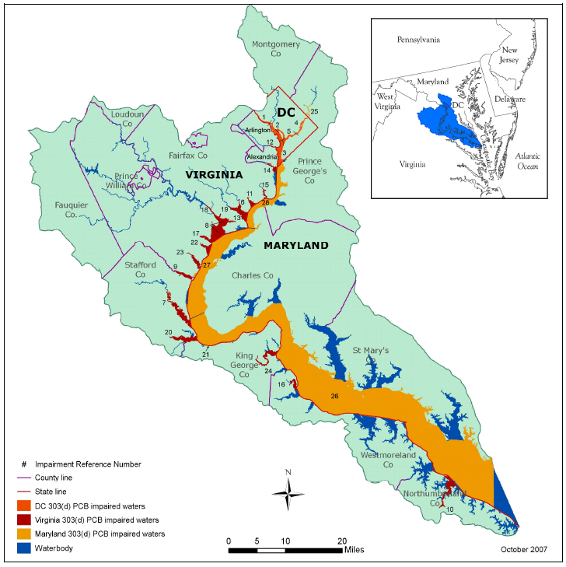
Figure 2. PCB impaired waterbodies in the lower Potomac River Basin (from Hayward and Buchanan, 2007).

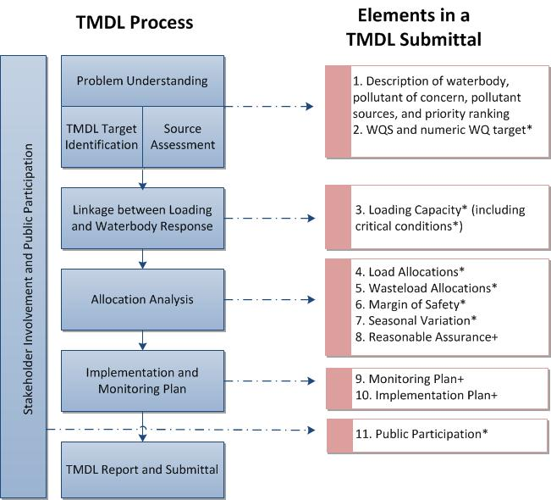
Figure 3. TMDL process and elements (from Tetra Tech, 2015).

Activities conducted for the Potomac River PCB TMDL which might be considered in terms of their vulnerability to various climate changes include (but are not limited to):
- Identification of PCB sources and modeling and analysis of associated PCB loads.
- Development and calibration of the linked hydrodynamic and PCB transport and fate model (POTPCB).
- Calculation of new water column PCB concentrations that would be protective of fish tissue concentrations.
- Calculation of PCB loads and load allocations (i.e. running of the POTPCB model with a series of loading scenarios to identify the impacts of individual sources, and then with an iterative series of input load adjustments to characterize a set of loads (the TMDL scenario) that would meet water column targets in all model segments.
- Selection, calculation, and utilization in modeling of various critical flows. For example, it is necessary to account for seasonality and critical conditions related to stream flow, loading, and water quality parameters. Seasonality and critical conditions are captured in the Potomac PCB TMDL using 2005 as the hydrologic design year. Baseline conditions for daily surface flows and loads of total suspended solids and particulate carbon come from 2005. During the period 2002 to 2007 from which flow data were available, Potomac River flows in calendar year 2005 most closely matched the river’s long-term harmonic mean flow (the flow condition recommended by EPA as the critical condition for TMDLs for substances whose human health impact is derived from lifetime exposure).
- The relative influences of flows and loading from one modeled river segment to another.
- Accounting for uncertainty in load estimates through calculation of a margin of safety (MOS).

Additional Supporting Information
Figure 4 shows how key steps in the TMDL process are linked to climate change assessment steps. Some key points of linkage include target identification and source assessment, characterization of pathways, assessment and modeling of loading and load reduction options, assessment of water body and ecological responses (risk assessment), remedial investigations and consideration of implementation options for remedial actions. In addition, determinations of waste load allocation are, in part, influenced by the responses of affected organisms/communities. Thus, climate change effects on and relative vulnerabilities of the various river resources identified in the Potomac River/Tributaries (e.g., surface & ground water, sediments, benthic invertebrates, fish tissue (bioaccumulation), birds & mammals, human health) are another linkage of interest.
From the PCB TMDL document (Hayward and Buchanan, 2007): “It is clear that progress toward achieving the Potomac PCB TMDL described in this report will require significant reductions from point, nonpoint, and atmospheric sources of PCBs to the estuary. The jurisdictions have agreed to proceed with an adaptive implementation approach using additional data collected concurrently with activities to reduce PCB loadings. New data and information will not necessarily re-open the TMDL, but the TMDL and allocation scenarios can be changed if warranted by new data and information.”
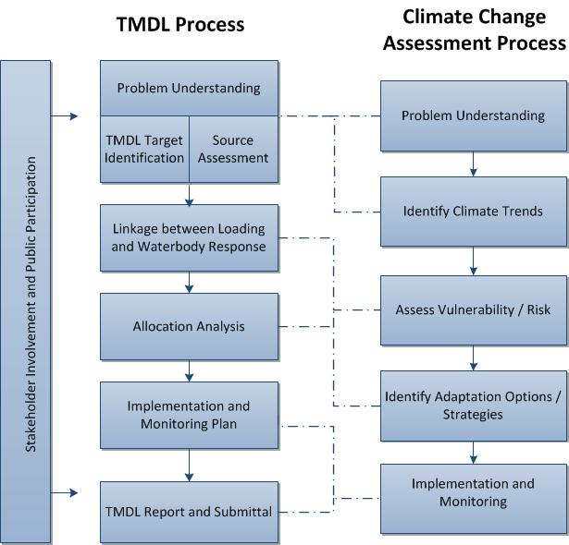
Figure 4. Linkages between TMDL and climate change assessment processes (from Tetra Tech, 2015).

Example Management Activity 3: Vulnerability of Virginia Waste Sites to SLR

Supporting Example: Hampton Roads/Norfolk Area Waste Site Facilities, Vulnerability to SLR.

Example Activity
Overarching questions regarding the locations and nature of key sources of contaminants to the Chesapeake Bay help drive the formulation of approaches (or strategies) and objectives for remediation. Ongoing and future climate changes, including sea level rise (SLR), storm surge, and associated frequencies of flooding, can impact land-based industrial or waste facilities and contaminated sediment sites, potentially increasing releases from already identified sources, or placing new sources at risk of contaminant release. This represents a large spatial scale (e.g., Bay-wide) of impact, with the potential of altering assumptions about the processes and pathways that contribute loadings to the Bay, and thus affecting strategy/approach-level decisions.
The example being considered is to examine the future risk of inundation of low-lying lands in the Hampton Roads/Norfolk, VA area of the lower Bay due to SLR and storm surge, and the associated threats to various types of waste facilities. This will be done using information from the Climate Central Surging Seas Risk Finder on the numbers of various types of waste-associated facilities in Virginia under future risk of inundation with SLR. In particular we will focus on EPA-listed waste sites (as well as some other facilities, structures, roads, etc.) that would be inundated at 5-feet above local high tide as a starting point for considering the potential additional exposure risks. This example provides an avenue for considering the implications of the vulnerabilities of these facilities, and how such information could affect strategies for meeting work group goals of reducing contaminant loading and effects in the Bay.
As an additional example, we present outputs from an EPA effort (by the Exposure Analysis and Risk Characterization Group, EPA Office of Research and Development) that identified and mapped waste facilities in the Norfolk, VA/Hampton Roads area of the southern Chesapeake Bay, as well as associated mapping of hurricane storm surge projections. The original objective for use of these results was to consider on a regional, rather than a single-site basis, how to sustain the functionality of municipal waste management across a system of sites that supports a large population, under the risk of a storm that could take out a few to several of the contributing units within the regional waste management system. This example provides an additional picture of how climate changes in SLR and storm surge can spatial pattern and number of waste facilities that may be at risk in the future.

Additional Supporting Information
Figure 5 maps areas of risk by category (low/medium/high) for inundation in the Hampton Roads/Norfolk area of Virginia based on SLR that would inundate 5 ft above mean high water (from the Climate Central Surging Seas Risk Finder (http://riskfinder.climatecentral.org/state/virginia.us?comparisonType=county&forecastType=NOAA2017_int_p50&impact=EPA&impactGroup=Contamination+Risks&level=5&unit=ft ).
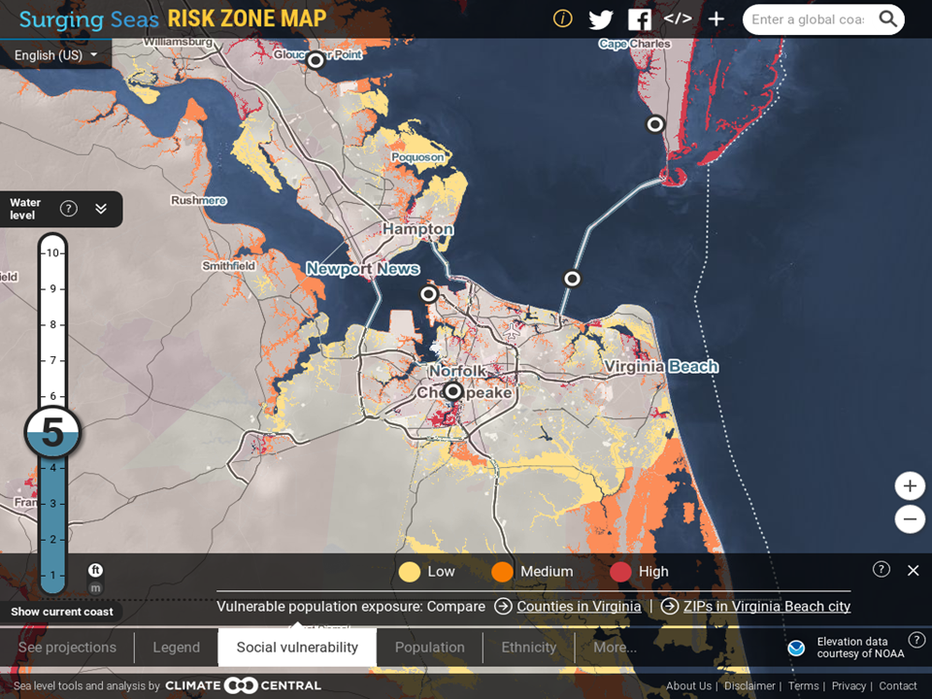
Figure 5. .Map of relative risk levels for inundation in the Hampton Roads/Norfolk area of Virginia based on SLR that would inundate 5 ft above mean high water (from the Surging Seas Risk Finder).

This website and associated report (Strauss et al. 2014) also gives results on number of facilities, structures, roads, etc. that would be inundated at 5-feet above local high tide (as well as for other increments of SLR). Some examples of infrastructure in Virginia on land less than 5 feet above the local high tide line include:
- 54,000 homes ($17.4 billion in property value, 107,000 residents, 1/3 in Virginia Beach).
- 1 power plant.
- 148 EPA-listed sites, screened to include mostly hazardous waste sites, facilities with significant hazardous materials, and wastewater generators.
- 32% of Norfolk Naval Shipyard, with one quarter of that area apparently protected or isolated.
- 13% of Naval Station Norfolk.
For context, in Delmarva as a whole on unprotected land below 5 feet there are:
- 183,000 people, 116,000 homes, $42 billion in property value.
- 401 EPA-listed sites.
Using enumeration of sites below 5 feet, as a moderate future SLR projection, Figure 6 maps a categorical summary of risk levels along Bay coastal counties in Virginia. The increasing risk (% likelihood) of flooding >5 feet in Virginia from 2016 through 2200 is shown in Figure 7.
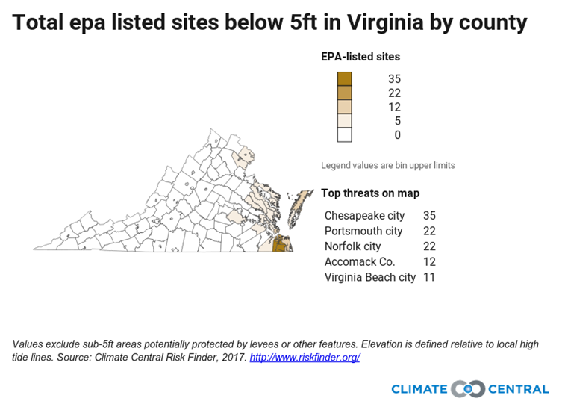
Figure 6. Threats to EPA-listed sites in Virginia based on SLR that would inundate 5 ft above mean high water (from the Surging Seas Risk Finder).

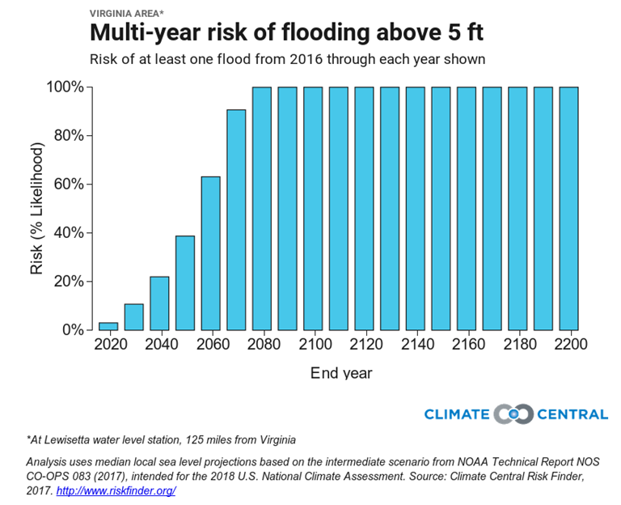
Figure 7. Multi-year risk of flooding above 5 feet in Virginia (from the Surging Seas Risk Finder, http://riskfinder.climatecentral.org/state/virginia.us?comparisonType=county&forecastType=NOAA2017_int_p50&impact=EPA&impactGroup=Contamination+Risks&level=5&unit=ft ).

For the example of waste facilities in the Norfolk/Hampton Roads area that serve the large regional population for municipal waste disposal, Table 1 lists the related waste facilities and they are mapped in Figure 8. Projections of the portions of land in this area that would be inundated by storm surges associated with hurricanes of different categories is shown as an overlay on the waste facilities map in Figure 9. This information gives some perspective on risks of waste facility inundation.

Table 1. List of Waste Facilities in the Norfolk, VA Region from I-WASTE
Name | Type
Hampton-NASA Steam Plant | Combustion/MSW Combustion Facilities
Wheelabrator Portsmouth Inc. | Combustion/MSW Combustion Facilities
Wheelabrator Portsmouth Inc. | Combustion/MSW Combustion Facilities
York County Transfer Station | Compost Facility
Marpol | Decontaminated Wastewater/Centralized Waste Treatment
Petrochem Recovery Services Inc. | Decontaminated Wastewater/Centralized Waste Treatment
HRSD – Army Base Sewage Treatment | Decontaminated Wastewater/POTW
HRSD – Boat Harbor Sewage Treatment | Decontaminated Wastewater/POTW
HRSD – Nansemond Sewage Treatment Plant | Decontaminated Wastewater/POTW
HRSD – Virginia Initiative STP | Decontaminated Wastewater/POTW
HRSD – York River Sewage Treatment | Decontaminated Wastewater/POTW
VDOT Interstate 64 Goochland Rest Area | Decontaminated Wastewater/POTW
Naval Base Norfolk | Government-Owned Land/Facilities
Portsmouth City - Craney Island Landfill | Landfills/Inert or Construction & Demolition (C & D) Landfills
Virginia Beach Landfill No. 2 | Landfills/Inert or Construction & Demolition (C & D) Landfills
USA Waste Of Virginia Landfills - Bethel Landfill | Landfills/MSW Landfills
Virginia Beach Landfill No. 2 | Landfills/MSW Landfills
Huntington Ingalls Incorporated-NN Shipbldg Div | Other/Electric Arc Furnaces
HRSD - James River Sewage Treatment | POTW; Other/Electric Arc Furnaces
Area Container Services Inc | Transfer Station
WMI / Recycle America Hampton Rds | Transfer Station
BFI / Chesapeake Transcyclery | Transfer Station
Craney Island Mat Rec Fac | Transfer Station
Newport News Materials Recovery | Transfer Station
Safety-Kleen / Chesapeake County | Transfer Station
SPSA / Chesapeake Transfer Station | Transfer Station
SPSA / Landstown Transfer Station | Transfer Station
VPPSA - King William County Transfer Station | Transfer Station

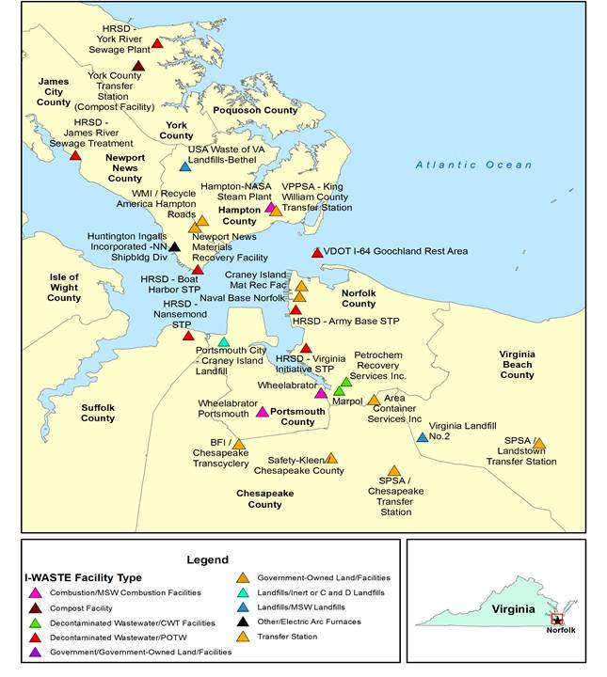
Figure 8. Map of Waste Facilities in the Norfolk, VA Region from I-WASTE.
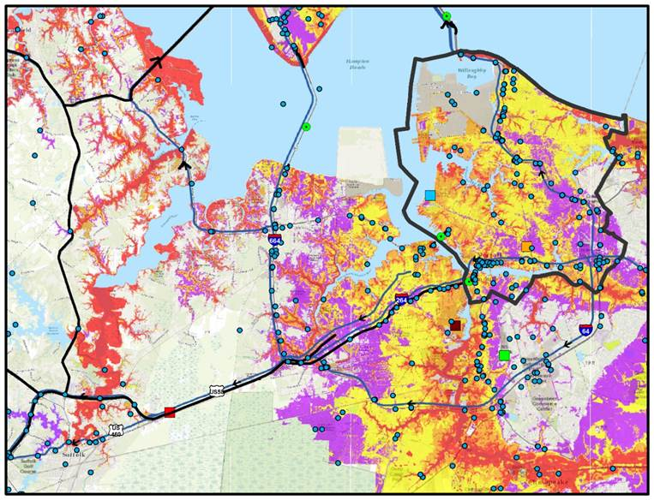
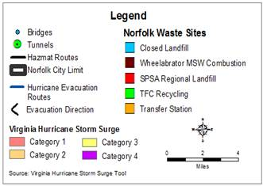
Figure 9. Overlap of Waste Facilities in the Norfolk, VA Region from I-WASTE with Hurricane Storm Surge Categories (from the Virginia Storm Surge Tool, http://www.vaemergency.gov/prepare-recover/threats/hurricane-storm-surge-maps/). From the Virginia Storm Surge Tool website – ‘“Storm surge” is an abnormal and potentially dangerous rise of water pushed to the shore by strong winds from a hurricane or tropical storm. It is also the main reason that evacuations are ordered. The storm surge zones of this map indicate the maximum area that may be inundated by a hurricane of a given value. This map is provided by the Virginia Department of Emergency Management (VDEM).

References
Haywood, H. C. and C. Buchanan. 2007. Total maximum daily loads of polychlorinated biphenyls (PCBs) for tidal portions of the Potomac and Anacostia rivers in the District of Columbia, Maryland, and Virginia. Interstate Commission on the Potomac River Basin. ICPRB Report 07-7. Rockville, MD.
Strauss, B., C. Tebaldi, S. Kulp, S. Cutter, C. Emrich, D. Rizza, and D. Yawitz. 2014. Virginia and the Surging Sea: A Vulnerability Assessment with Projections for Sea Level Rise and Coastal Flood Risk. Climate Central Research Report. 31 pp. www.climatecentral.org.
Tetra Tech. 2015. EPA Region 10 Climate Change and TMDL Pilot Process Roadmap: Conceptual Framework and Procedures. 13 pp.

Example management activities are grounded in Toxic Contaminants Workgroup approaches (e.g., linking with the TMDL process, an initial focus on PCBs), and the background information presented represents this factual basis. But any specific projects or actions presented are examples only, not actually being considered or recommended.

