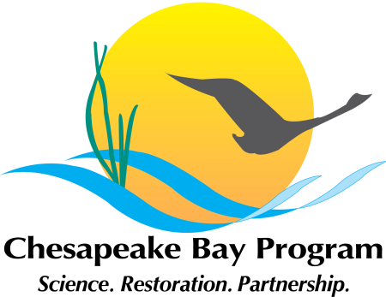
As of 9.28.16
Chesapeake Executive Council
2016 Annual Meeting
Location: Arboretum of Virginia
Boyce, VA
October 4, 2016
10 a.m. to 12 noon
Annotated Agenda
Themes: Recognize Successes
Collaborate for Progress
Commit to Finding Solutions

9:45-10:00 EC members arriving; take seats

10:00 a.m. - 11:00 a.m. Private Breakfast
10:00-10:10 Follow-up on 2015 EC Meeting Actions – Molly Ward, PSC Chair
Includes:
- Environmental Finance Symposium
- Rivers of the Chesapeake Letter
- Riparian Forest Buffers Resolution
- Stream Bank Exclusion
10:10-10:35 Advisory Committee Reports and questions (5 minutes each with discussion)
- Citizens’ Advisory Committee – Lead: Charlie Stek, Chair
- Local Government Advisory Committee – Lead: Bruce Williams, Vice-Chair
- Scientific and Technical Advisory Committee – Lead: Lisa Wainger, Chair

10:35-10:50 Discussion and Action - Lead: Governor McAuliffe, EC Chair
  - Local Government Engagement Resolution
  - Discussion of challenges and solutions

10:50-10:55 Nomination and Election of Executive Council Chair
10:55-10:57 Briefing on Press Event – Rachel Felver, CBP Communications Director
(Alliance for the Chesapeake Bay)
10:57-11:02 Group Photo – just outside of library – Will Parson, CBP Photographer (Alliance for the Chesapeake Bay)
11:02-11:05 EC transition to Public meeting w/ press conference – guide: Rachel Felver
-------
11:05 – 12:00 Public Meeting with Press Conference
11:05-11:07 Welcome to Arboretum – Univ. of Virginia President, Teresa Sullivan
11:07-11:12 EC Public Meeting Opening, Purpose – Gov. McAuliffe (VA), EC Chair
11:12-11:17 State of the Program Report– Nick DiPasquale, CBP Director
11:17-11:22 Presentation on Chesapeake Bay Comprehensive Plan – Brigadier General William Graham, USACE
11:22-11:47 Discussion/remarks on challenges and solutions – All EC members
11:47-11:50 EC Chair McAuliffe Gavels Public portion to a close, closing remarks
Open Press Conference – EC Chair
11:50-12:00 EC Panel for media Q&A – Gov. McAuliffe to facilitate
12:00 EC Chair Gavels event to a close

POSTERS
Showing signs of resiliency and progress:
1. SAV
2. Water Quality Monitoring Trends
3. Oyster Restoration
4. Blue Crab Population

Showing that with collaboration, we can get things done:
1. Wastewater
2. Air Reductions

